DRIVING thru the BIBLE

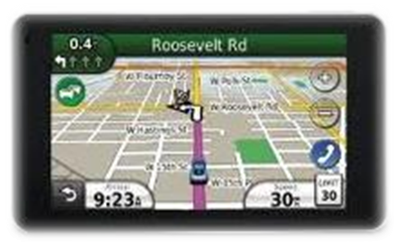

Strategies to Kill the Messiah

Old Testament

- Destroy Adam and Eve Gen 3

- Corruption of Adam’s line (flood) Gen 6

- Abraham’s seed (Isaac, Jacob, Joseph) Gen 12, 20

- Famine in the Land Gen 50

- Destruction of male line (Pharaoh to kill Hebrew babies) Exo 1

- Pharaoh’s pursuit after releasing Israelites Exo 14

- Populating of Canaan (giants, forts, etc.) Gen 12:6

- David’s blood line (Solomon/Nathan) 2 Sam 7

- Jehoram kills his brothers 2 Cron 21

- Arabians slew all but Ahazariah 2 Cron 21

- Queen Athaliah kills all but Joash 2 Cron 22

- Hezekiah assaulted, etc Isa 26, 38

- Haman’s attempts in Persia Ester 3

New Testament

- Joseph unsure whether to marry Mary Matt 1

- King Herod’s attempts (babies 2 and younger killed) Matt 2

- At Nazareth (Satan tempts Christ; Jews try to throw Him off a cliff) Luke 4

- 2 storms on the sea (professional fishermen frightened!) Mk 4; Luke 8

- The Cross!! The Gospels

- 2nd Coming (prevent Jews from believing/asking Christ to return) Rev 12

