DRIVING thru the BIBLE

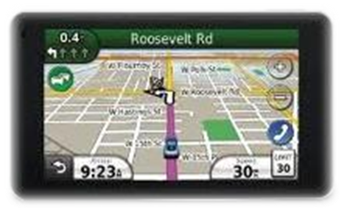

The Parable of C-R-U-I-S-E Control

Christ - Redeems - Unconditionally - If - Sinners - Exchange - Control

Remember when the only gadget on the left side of the steering column was a thin pencil shaped “stalk” that just operated the turn signals … push up for a right turn; pull down for a left turn! Nowadays many other switching features that were once controlled from other places within the reach of the driver are now controlled from that one location on the steering column: the windshield wipers can be turned on and off, wiper speed can be adjusted, washer fluid can be squirted on the windshield, and in some cases, a neat feature called “cruise control” can be operated from that one location.

In general, self regulating cruise control systems in automobiles are used to do what humans cannot do very efficiently on their own: react quickly, and in proportion, to “slight” changes in speed. Self regulating cruise control systems installed in modern automobiles (also known as a speedostat) were first invented in 1945 by the blind inventor and mechanical engineer Ralph Teetor. His idea at that time was born out of the frustration of riding in a car driven by his lawyer, who kept speeding up and slowing down as he talked.

An even greater frustration exists for motorists in the 21st century: the sky high price of fuel! Mostly everyone knows that the stop and go driving patterns around town are murder on gas mileage; the same is true when using the speed up and slow down pattern on long road trips. You not only wear your leg out pushing up and down on the accelerator pedal, your wear out your wallet paying for gas at the gas pump!

Our Original Equipment Manufacturer, JESUS, offers us His own brand of cruise control. He knew when He created us that we would not react in proportion to events that occurred while driving our way down that stop and go Road Trip called life. He knew that the pull of the flesh would be so strong that it would distract us from keeping our eyes on the road and our minds on the destination. We too would wear ourselves out worrying about the high price of speeding up and slowing down every time something new and fresh came along.

So He sacrificed himself on the cross to provide each of us with the necessary trust and peace of mind to allow Him to send the Holy Spirit to live within us to be our “spiritual” cruise control system. If we turn our lives over to Him, He promised us that we would no longer need to be anxious about our having to pay the high price of our speeding up and slowing down: “My yoke is easy and My burden is light”, He tells us in Matthew 11:30. So ask Jesus to come into your life today and start experiencing the mileage increasing blessings of His:

C-R-U-I-S-E Control System

Christ - Redeems - Unconditionally - If - Sinners - Exchange - Control!

